**README for T-AI**

How to use T-AI (undergraduate students version):

1. Copy and paste the following website to your browser search bar.

<https://www.figma.com/proto/LpBMejATUXyUJ6UPPIl33H/EMIA-2020-UI-Prototype?type=design&node-id=206-1247&t=y3EfoyTkxHoN36v8-0&scaling=min-zoom&page-id=206%3A1241&starting-point-node-id=206%3A1247&show-proto-sidebar=1>



1. On the right side, click “Options”, and then click “Fit to screen”.

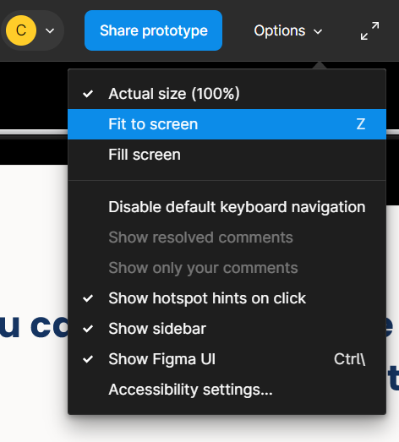

1. You should see the following pages after step 2. Click the pull down menu in the middle and click “MATH1012”.

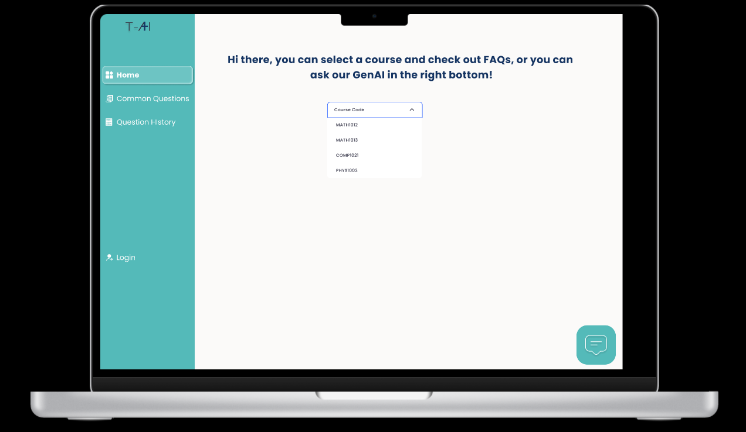

1. You should see the FAQs of MATH1012. Click “2. Different types of primary functions”.

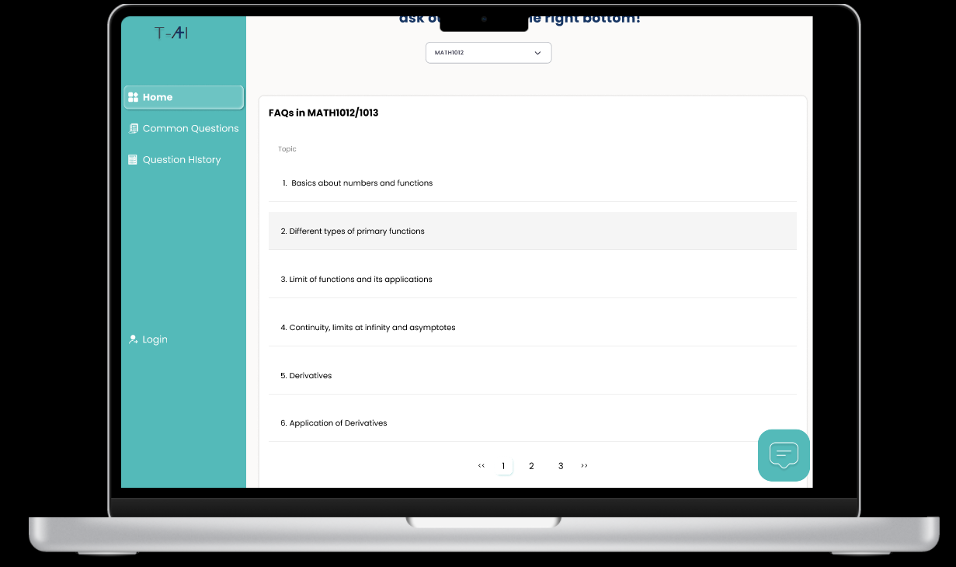

1. You should see the FAQs of Different types of primary functions. Click “1. Exponential functions”.

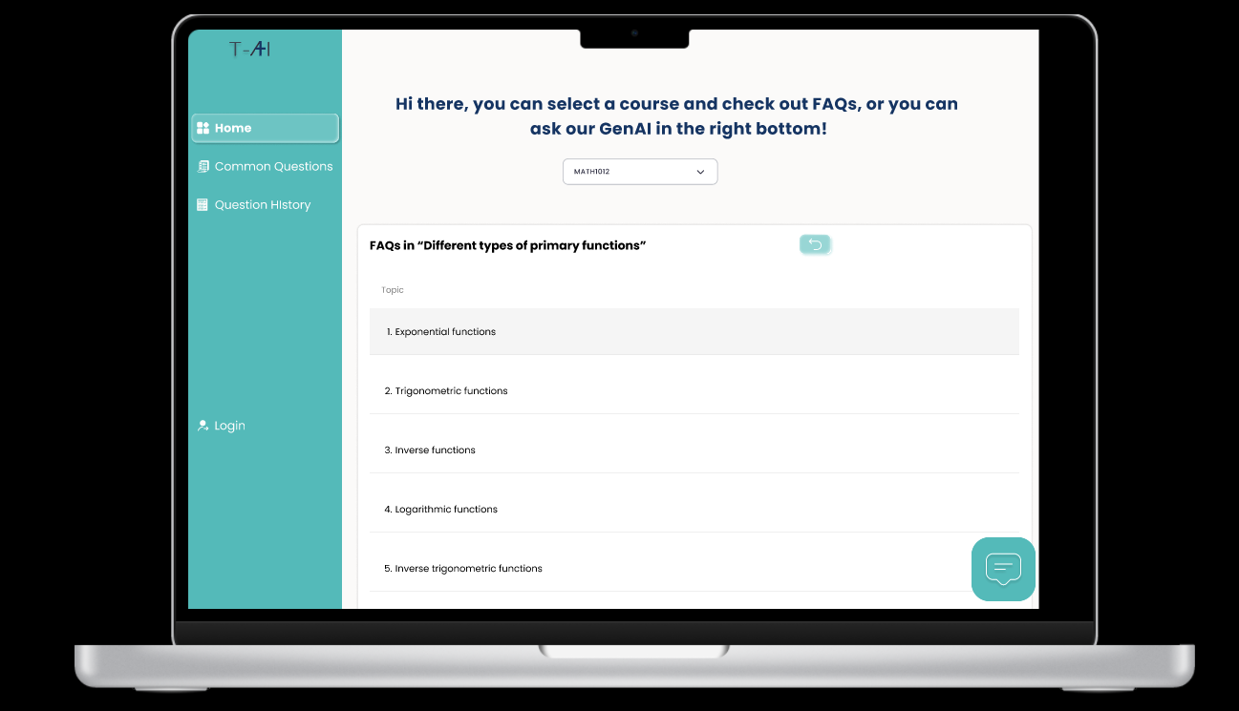

1. You should see the FAQs of Exponential functions. Click the 3rd question.

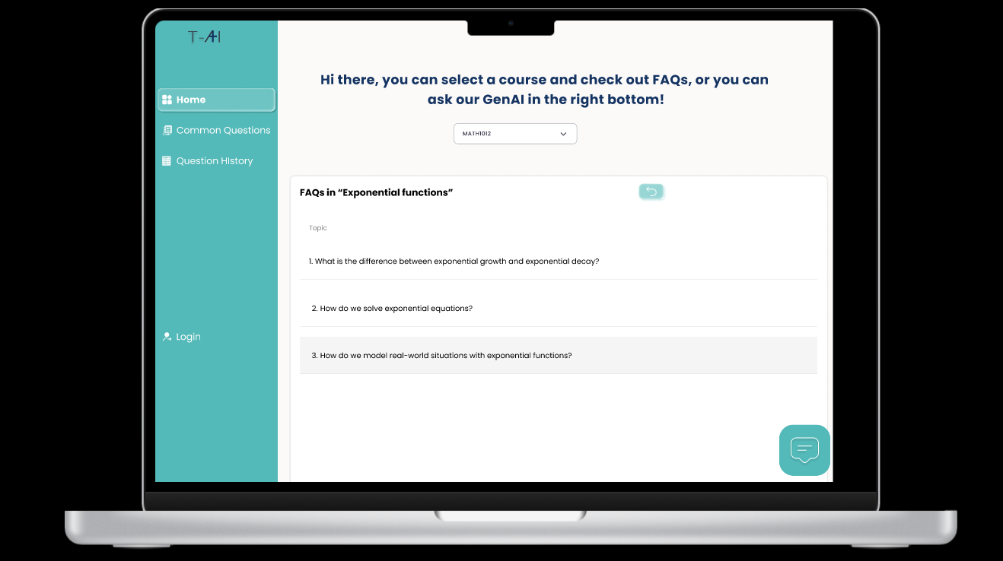

1. You should see the corresponding solution for this question.

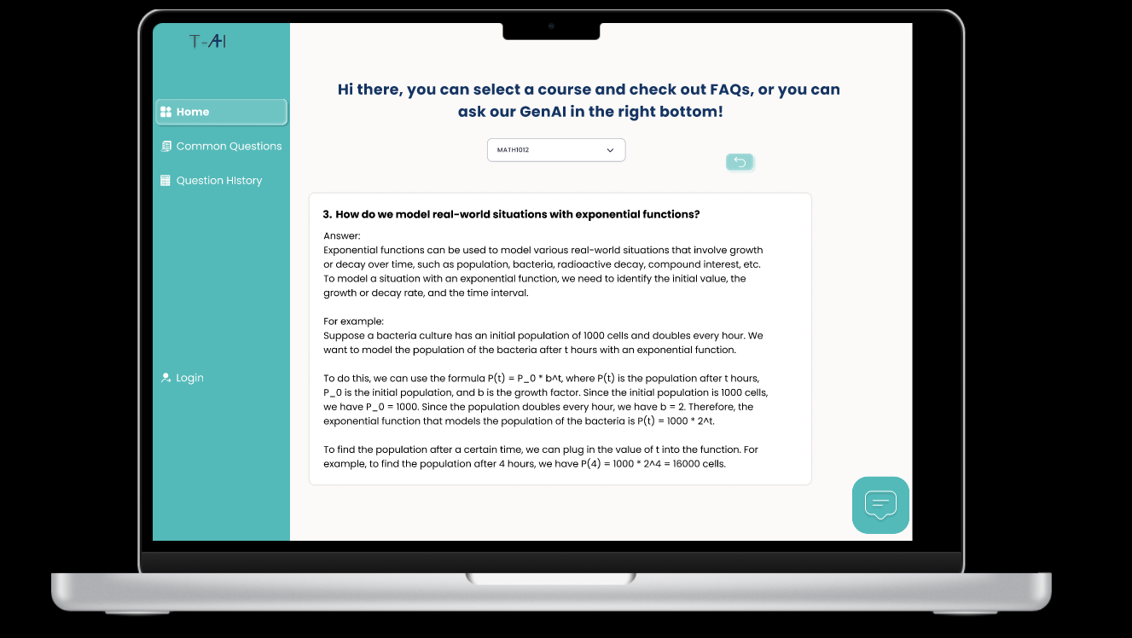

1. Click “Common Questions” on the left side bar. You should see the following.

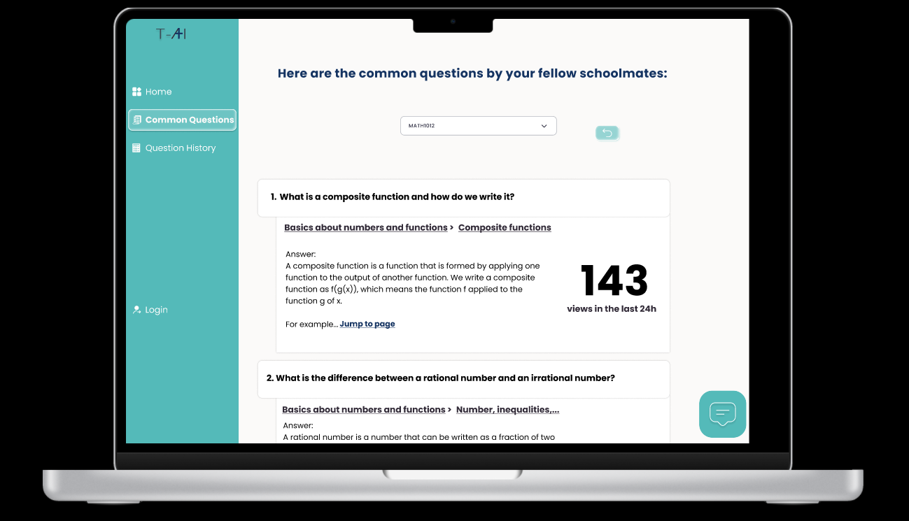

1. Click “Question History” on the left side bar. You should see the following.

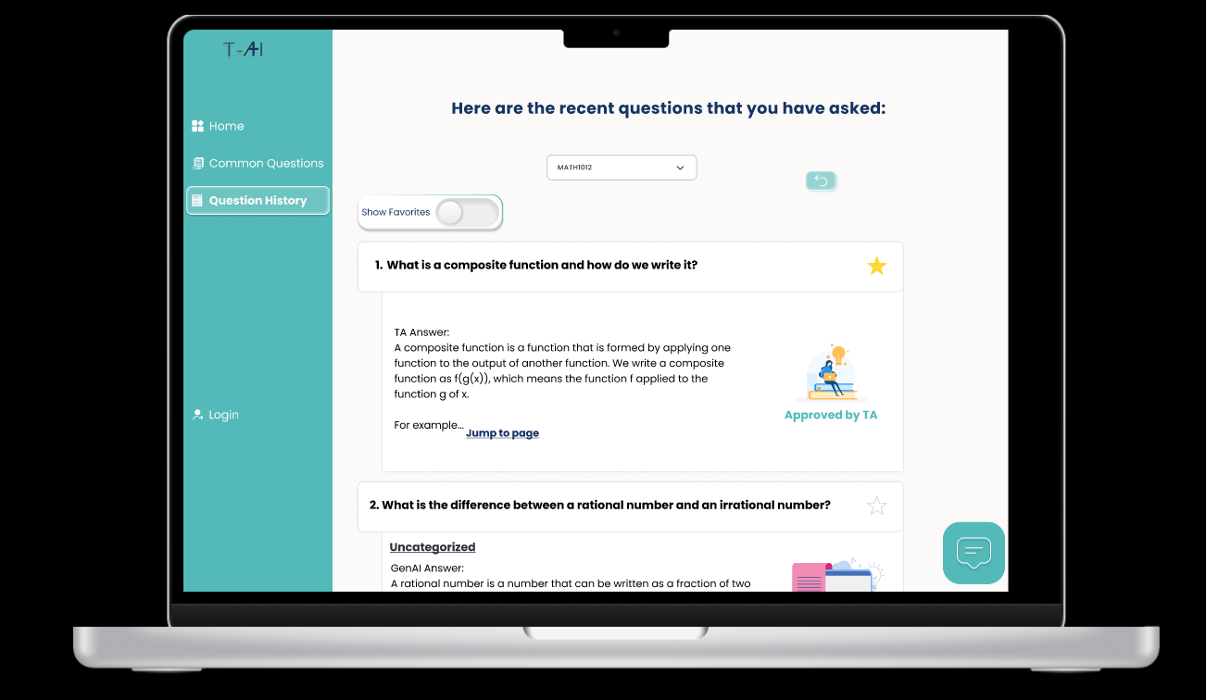

1. You can click the “Show Favourites” switch to see your favorite questions denoted with a yellow star.

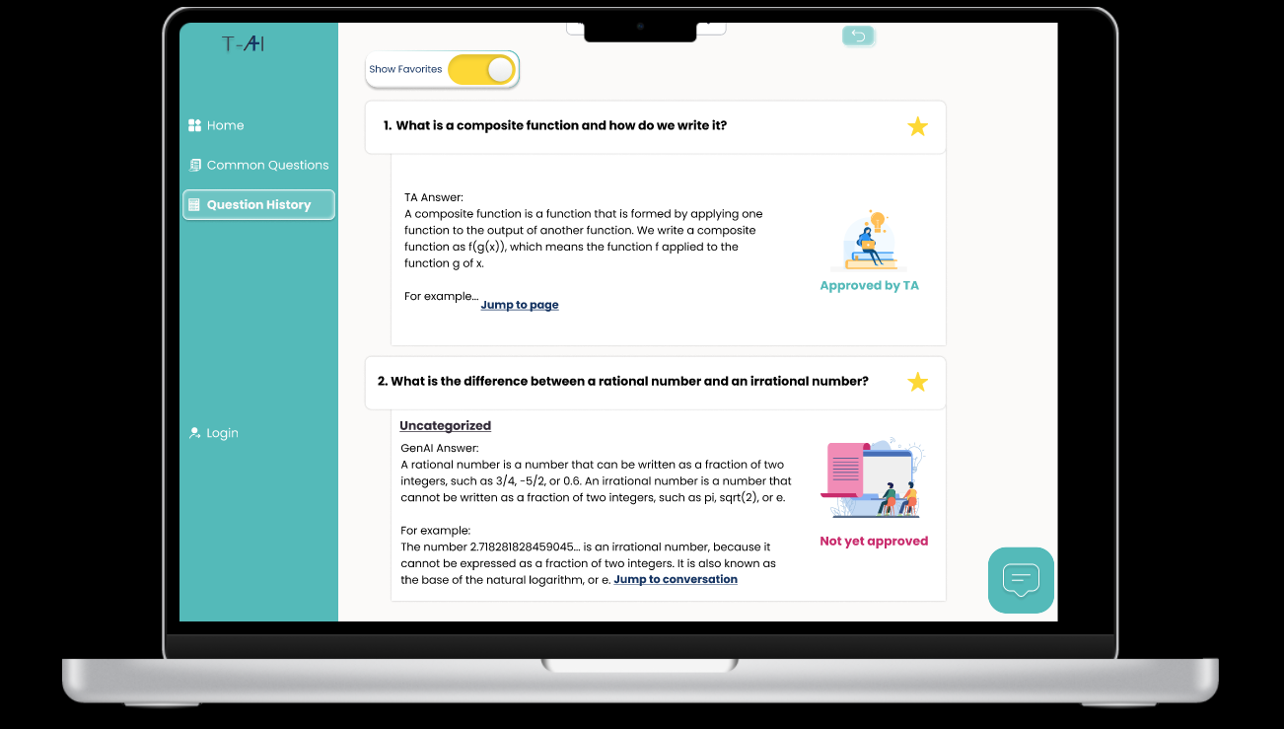

1. Click the conversation button on the bottom right corner to toggle the AI feature.

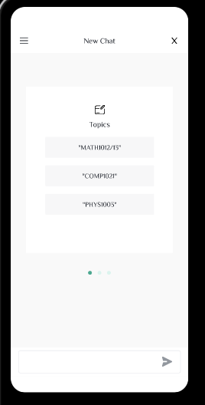

1. Click “MATH1012/13”. You should see the AI generated answer.

